**Student Attendance System Using QR-Code**

**(or)**

**QR Code Based Smart Online Student Attendance System**

**ABSTRACT:**

This project presents the development of a QR Code Based Smart Online Student Attendance System using Java with JSP, HTML, CSS, and JavaScript for frontend development and MySQL for database management. The system facilitates efficient tracking of student attendance while ensuring authentication and preventing unauthorized access.

The system comprises two main entities: Student and Staff. Students register by providing comprehensive details including Roll Number, Year, Department, Photo, Name, email id, phone number, address, and password. However, student login access is granted only after staff verification and approval, preventing anonymous access.

Upon approval, students can log in to the system and download their ID Card containing a unique QR code. This QR code serves as a means for students to mark their attendance by presenting the ID card to a webcam. The system distinguishes between valid and invalid QR codes, ensuring accurate attendance recording. Additionally, a picture is captured each time attendance is marked, facilitating later verification if needed.

Students have access to their attendance logs, allowing them to monitor their attendance record. Staff members can easily calculate student attendance by selecting the student and month, with the system providing the total number of days present. Moreover, staff can view attendance logs for all students, complete with attendance pictures, ensuring comprehensive monitoring and record-keeping.

Overall, the QR Code Based Smart Online Student Attendance System offers a convenient and secure method for managing student attendance, promoting accountability and efficiency in academic institutions.

**EXISTING SYSTEM:**

* Before the implementation of the QR Code Based Smart Online Student Attendance System, the existing method of managing student attendance was employed. In the existing system, attendance tracking was typically conducted manually or using rudimentary electronic methods.
* Manual Attendance Tracking: In the existing system, in many educational institutions, student attendance was manually recorded using attendance registers or sheets. This involved teachers or administrative staff physically marking attendance for each student in a designated register during class sessions.
* Paper-Based ID Cards: In the existing system, students were issued paper-based ID cards containing their basic information such as name, roll number, and photograph. These ID cards were used as a means of identification but did not incorporate any technological features for attendance tracking.
* Staff Verification: In the existing system, student attendance was often reliant on staff members manually verifying the presence of students during class sessions. This process involved visually confirming the identity of students and recording attendance accordingly.
* Lack of Real-Time Monitoring: Since attendance records were maintained manually, there was a lack of real-time monitoring and tracking. Attendance data had to be manually compiled and processed, leading to delays in accessing up-to-date information.
* Time-Consuming Data Management: Managing attendance records manually was a time-consuming task for both students and staff. It required significant administrative effort to maintain accurate records, reconcile discrepancies, and generate attendance reports.
* Limited Accessibility: Attendance records were typically stored in physical registers or on local computer systems, limiting accessibility to authorized personnel within the educational institution.
* Overall, the existing system relied heavily on manual processes and lacked the efficiency, accuracy, and convenience offered by modern technological solutions. The transition to the QR Code Based Smart Online Student Attendance System represents a significant upgrade in attendance management, leveraging technology to streamline processes, enhance security, and improve overall efficiency.

**DISADVANTAGES OF EXISTING SYSTEM:**

* Prone to Errors: In the existing system, manual attendance tracking is inherently susceptible to human errors, such as illegible handwriting, misinterpretation of attendance marks, or accidental omissions. These errors can compromise the accuracy of attendance records and lead to discrepancies in student attendance data.
* Time-Consuming: In the existing system, recording attendance manually is a time-consuming process for both students and staff. It requires significant time and effort to pass around attendance registers, mark attendance for each student, and later compile and reconcile attendance data.
* Lack of Real-Time Monitoring: In the existing system, manual attendance tracking does not allow for real-time monitoring of student attendance. Attendance data is typically updated after the class session or at the end of the day, leading to delays in accessing up-to-date information.
* Limited Accountability: In the existing system, with manual attendance tracking, there is limited accountability in ensuring the accuracy and authenticity of attendance records. It may be difficult to verify the attendance of individual students, especially in large class settings, leading to potential discrepancies and inaccuracies.
* Accessibility Issues: In the existing system, attendance records maintained manually may be stored in physical registers or on local computer systems, limiting accessibility to authorized personnel within the educational institution. This can hinder efficient data retrieval and analysis, especially for administrative purposes.
* Difficulty in Data Analysis: In the existing system, analyzing attendance data manually can be challenging and time-consuming. Staff may encounter difficulties in identifying attendance trends, patterns, or anomalies, which are crucial for making informed decisions regarding student performance and engagement.
* Security Concerns: In the existing system, paper-based ID cards used for identification purposes may be susceptible to loss, theft, or duplication. This raises security concerns regarding the integrity of student identification and attendance tracking, potentially compromising the overall security of the educational institution.
* Inefficient Communication: In the existing system, manual attendance tracking systems may lack integration with other communication channels, making it difficult to notify students or staff regarding attendance-related matters in a timely manner. This can lead to inefficiencies in communication and coordination within the educational institution.
* Overall, the disadvantages of the existing manual attendance tracking system highlight the need for a more efficient, accurate, and technologically advanced solution such as the QR Code Based Smart Online Student Attendance System.

**PROPOSED SYSTEM:**

* The proposed system, the QR Code Based Smart Online Student Attendance System, introduces a modern and technologically advanced approach to student attendance management.
* QR Code Integration: The core feature of the proposed system is the integration of QR codes for student attendance tracking. Each student is provided with a unique ID card containing a QR code. This QR code serves as a secure and efficient method for students to mark their attendance using a webcam.
* User Authentication: The system incorporates a user authentication mechanism to ensure secure access to the system. Students and staff members are required to log in with their credentials (username and password) to access the system's features and functionalities.
* Student Registration: Students are required to register in the system by providing their personal information, including their roll number, year, department, contact details, and a photograph for identification purposes. Upon registration, students' accounts are created in the system for further verification by staff members.
* Staff Approval Workflow: After student registration, staff members are responsible for verifying and approving student accounts. Staff members review the details provided by students and approve or reject their accounts accordingly. Only approved students are granted access to the system for attendance marking.
* Attendance Marking: Once their accounts are approved, students can log in to the system and download their ID card containing the QR code. During class sessions, students can mark their attendance by presenting their ID card to a webcam, which scans the QR code and records their attendance in the system.
* Attendance Logging: The system maintains comprehensive logs of student attendance, including the date and time of attendance marking. These attendance logs are accessible to both students and staff members for monitoring and reference purposes.
* Attendance Analysis: Staff members have access to advanced features for analyzing student attendance data. They can view attendance reports, calculate attendance percentages, and identify attendance trends over time. This facilitates informed decision-making and intervention strategies to improve student engagement and performance.
* Secure Data Management: The proposed system ensures the secure management of student attendance data. Attendance records, personal information, and authentication credentials are stored in a centralized database (MySQL) with appropriate security measures to protect against unauthorized access and data breaches.
* Overall, the proposed QR Code Based Smart Online Student Attendance System offers a comprehensive solution for efficient and secure student attendance management in educational institutions. It leverages QR code technology and user authentication to streamline attendance tracking while providing advanced features for data analysis and monitoring.

**ADVANTAGES OF PROPOSED SYSTEM:**

* Enhanced Accuracy: The use of QR codes for attendance marking significantly reduces the likelihood of errors compared to manual methods. QR codes ensure precise and automated recording of student attendance, minimizing the risk of inaccuracies and discrepancies in attendance data.
* Improved Efficiency: The proposed system streamlines the attendance tracking process, saving time and effort for both students and staff members. With the ability to mark attendance using QR codes and automated data processing, the system eliminates the need for manual attendance recording and data entry, leading to increased efficiency in attendance management.
* Real-Time Monitoring: Unlike manual attendance systems, the proposed system allows for real-time monitoring of student attendance. Attendance records are updated instantly as students mark their attendance using QR codes, providing administrators and educators with up-to-date information on student attendance status.
* Enhanced Security: The use of QR codes and user authentication mechanisms enhances the security of the attendance tracking system. QR codes are unique to each student and are difficult to duplicate or tamper with, reducing the risk of attendance fraud or unauthorized access to the system.
* Convenient Access: Students and staff members can access the attendance system conveniently from any device with internet connectivity. The system's web-based interface enables users to log in and mark attendance, view attendance logs, and generate reports from anywhere, at any time, facilitating seamless attendance management.
* Comprehensive Reporting: The proposed system offers advanced reporting and analytics features for analyzing student attendance data. Staff members can generate detailed reports, track attendance trends, and identify patterns or anomalies, empowering them to make informed decisions and implement targeted interventions to improve student engagement and performance.
* Simplified Administration: Automated processes and centralized data management simplify administrative tasks related to attendance tracking. Staff members can easily verify student accounts, approve or reject registrations, and manage attendance records with minimal manual intervention, reducing administrative burden and improving workflow efficiency.
* Student Engagement: The adoption of a modern and technology-driven attendance tracking system can enhance student engagement and accountability. The interactive nature of QR code-based attendance marking encourages active participation from students, fostering a sense of responsibility towards their attendance and academic progress.
* Overall, the proposed QR Code Based Smart Online Student Attendance System offers numerous advantages over traditional manual attendance systems, including improved accuracy, efficiency, security, accessibility, and reporting capabilities, ultimately contributing to enhanced student success and institutional effectiveness.

**SYSTEM ARCHITECTURE:**

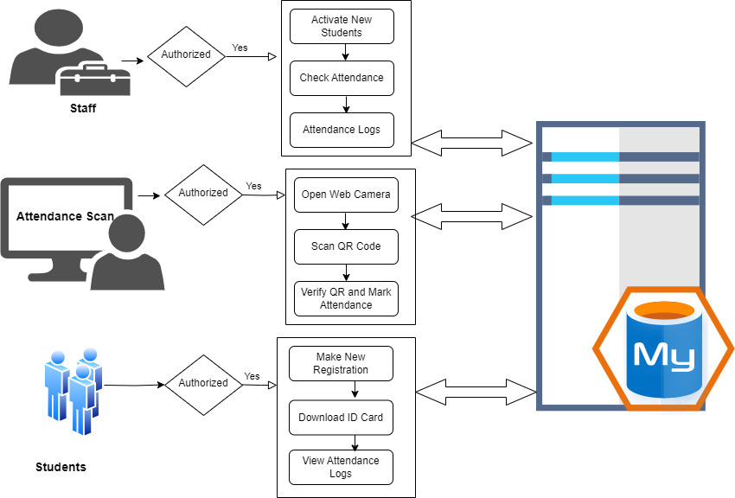

**MODULES:**

* Registration and Authentication Module
* Attendance Management Module
* Staff Approval Workflow Module
* Reporting Module

**MODULES DESCSRIPTION:**

**Registration and Authentication Module:**

This module handles the registration process for both students and staff members, collecting necessary information such as personal details and contact information. Upon registration, users' credentials are authenticated to ensure secure access to the system. For students, the registration process includes uploading a photograph for identification purposes. Staff members are responsible for reviewing and approving student registrations before they can access the system. Authentication mechanisms are implemented to verify the identity of users logging into the system, preventing unauthorized access.

**Attendance Management Module:**

The core functionality of the system revolves around the attendance management module, which facilitates the marking and tracking of student attendance. Students can download their unique ID cards containing QR codes, which are used to mark attendance during class sessions. The module includes features for scanning QR codes using a webcam, recording attendance data in real-time, and preventing duplicate attendance entries for the same day. Attendance logs are maintained securely in the system, allowing both students and staff members to monitor attendance records and track attendance trends over time.

**Staff Approval Workflow Module:**

This module manages the workflow for staff approval of student registrations. Upon registration, student accounts are submitted for staff review and approval. Staff members have access to a dashboard where they can view pending registration requests, review student details, and approve or reject registrations accordingly. The module includes communication features to notify students of the status of their registration requests and provide feedback in case of rejection. Staff members can also track the status of approved and rejected registrations for administrative purposes.

**Reporting Module:**

The reporting module provides staff members with tools for analyzing student attendance data and generating comprehensive reports. Staff members can generate attendance reports by selecting specific criteria such as student, date range, or course. The module includes features for calculating attendance percentages, identifying attendance trends, and generating graphical representations of attendance data for easy visualization.

**SYSTEM REQUIREMENTS:**

**HARDWARE REQUIREMENTS:**

* System : Pentium i3 Processor.
* Hard Disk : 500 GB.
* Monitor : 15’’ LED.
* Input Devices : Keyboard, Mouse.
* Ram : 4 GB.

**SOFTWARE REQUIREMENTS:**

* Operating system : Windows 10/11.
* Coding Language : JAVA.
* Frontend : JSP, HTML, CSS, JavaScript.
* JDK Version : JDK 21.
* IDE Tool : Apache Netbeans IDE 20.
* Tomcat Server Version : Apache Tomcat 9.0.84
* Database : MYSQL.